**Table of Contents**

**Part 2: Documentation** 3

**1.** **Abstract** 3

**2.** **Problem Statement** 3

**3.** **Types/ Categories of Expert System** 4

**I.** **Knowledge Base:** 4

**II.** **Inference Engine:** 4

**III.** **Knowledge acquisition and learning module:** 4

**IV.** **User Interface:** 4

**V.** **Explanation Module:** 4

**4.** **Literature Review** 5

**What is meant by ChatBot?** 5

**5.** **Semantic network** 6

**6.** **Test plan / Screen shots of special features** 7

**7.** **Results of user acceptance testing** 7

**8.** **Coding Implementation** 8

**9.** **Future Enhancement and improvement of the system:** 9

**I.** **Multi-Language (multilingual) Chatbot:** 9

**II.** **Communicating with voice/speech/call:** 9

**III.** **Improve chatbot processing capabilities:** 9

**10.** **Conclusion:** 9

# **Part 2: Documentation**

## **Abstract**

The purpose of this study is mainly to serve as an information repository and consultant. The aim is to increase visibility in this industry, make it simple, convenient and free of hassle for the client to communicate with their potential customers. The project helps users perform all their requirements within the field with the ease of an automated Chatbot.

## **Problem Statement**

1. Several big or small business/companies can receive calls or messages or live complain about certain problems or questions that their client/customers may be having/facing and they can’t answer to all at the same time. To overcome this problem a Chatbot is one of the best options out there for any company as this would help the company/organization handle clients/customers without having the trouble of answering all the calls/questions at the same time, instead they can implement this option which will allow the client/customer to communicate with them and solve/answer to their problems.
2. When your company is small or medium-sized, it is difficult to keep your doors open 24 hours a day, seven days a week. Customers don't have a set time to shop, therefore they're more likely to browse your website after you've already closed for the day. Chatbots are becoming more relevant at this point. They can keep your consumers entertained by answering their inquiries.
3. An AI chatbot is one of your finest tools when the amount of your incoming inquiries exceeds the capacity of your human support team. Chatbots may be trained to answer frequently asked questions in real time, and their machine learning skills allow them to understand the underlying questions' purpose, allowing them to have richer, more informative, and ultimately more fulfilling discussions with customers. This streamlines the process of providing assistance to customers and guarantees that customers get the aid they require.
4. Companies do also need to gather data from customers such as their likings, their satisfaction for a product or services and to do this a large amount of data is required and companies all alone cannot do it by themselves. So, in this case a Chatbots may also be utilised to generate leads. Chatbots may qualify leads and gather information about potential consumers by asking users a series of questions. This data may then be utilised to tailor marketing messages to certain demographics.

## **Types/ Categories of Expert System**

1. **Knowledge Base:** The data and rules that make up an expert system are stored in its knowledge base. It incorporates domain-specific knowledge and norms for problem-solving and method-formulation**.**
2. **Inference Engine:** The inference engine's primary function is to analyse the knowledge base for relevant information that may be used to solve the user's problem. In addition to inferring, inference engines may explain and resolve problems.
3. **Knowledge acquisition and learning module:** Expert systems' data collection and analysis capacity is greatly enhanced by the knowledge acquisition and learning module. After that, it is added to the database of previously acquired information.
4. **User Interface:** The user interface is the point of contact between the expert system and the user, who need not be an expert in the subject matter.
5. **Explanation Module:** This module provides the user with an explanation of why the conclusion was reached.

## **Literature Review**

### **What is meant by ChatBot?**

A chatbot is an artificial intelligence that can carry on conversations with humans using text messages, voice instructions, or a combination of the two. Chatbot, short for chatterbot, is an AI component that can be integrated into and used with virtually any popular chat program.

In accordance to our assignment, A chatbot is a form of automated software that simulates human conversation with consumers at low or no expense to the business. Customer service chatbots are available 24/7/365, regardless of location or time of day. This makes its adoption more attractive to companies who lack the resources to maintain a round-the-clock workforce.

A chatbot's conversational abilities are restricted when it must adhere to predetermined rules. It is limited in what it can do and what it can say, and its intelligence is directly proportional to the quality of its coding.

A financial automation bot that prompts the caller with questions to determine their desired action is an example of a restricted bot.

## **Semantic network**

The pictures above are the main source for the working of this chatbot. This actually trains the chatbot to answer based on what questions are been asked. Everything works in a proper flow manner and the bot answers to what is already fed in the machine.

The above pictures also show how a chatbot would communicate with a user in a flow manner based on questions. This is just the visual way of representing the working of the chatbot and how it works in a step-by-step manner.

## **Test plan / Screen shots of special features**

|  |  |  |  |
| --- | --- | --- | --- |
| **Test No.** | **Test Name** | **Purpose of Test** | **Expected Result** |
| 1. | Implementation of methods | Test for the methods implemented | Since we are implementing ListTrainer, output should show that the ListTrainer is at 100%. |
| 2. | Response Test | To test whether the response given is logical. | The response of the Chatbot regarding the chosen topic will have to be logical and useful to the user. |
| 3. | Chatbot Test | To test the Chatbot. | The Chatbot responds with proper answers to the user. |

## **Results of user acceptance testing**

|  |  |  |  |  |
| --- | --- | --- | --- | --- |
| **Test No.** | **Acceptance Criteria** | **Purpose of Test** | **Priority** | **Test Result** |
| 1. | AppropriateResponse Test | To test whether the response given is logical. | High | Accepted |
| 2. | Low response latency. | To test how fast bot response to the questions. | Mid | Accepted |
| 3. | End chat properly | To check if the bot ends the chat appropriately. | High | Accepted |

## **Coding Implementation**

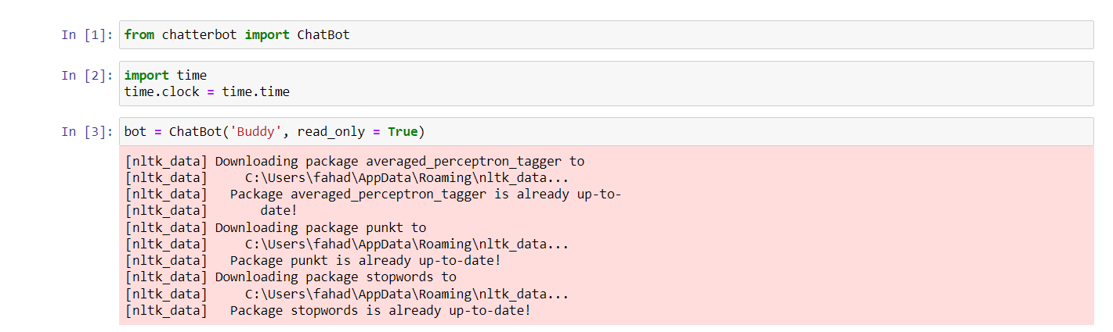

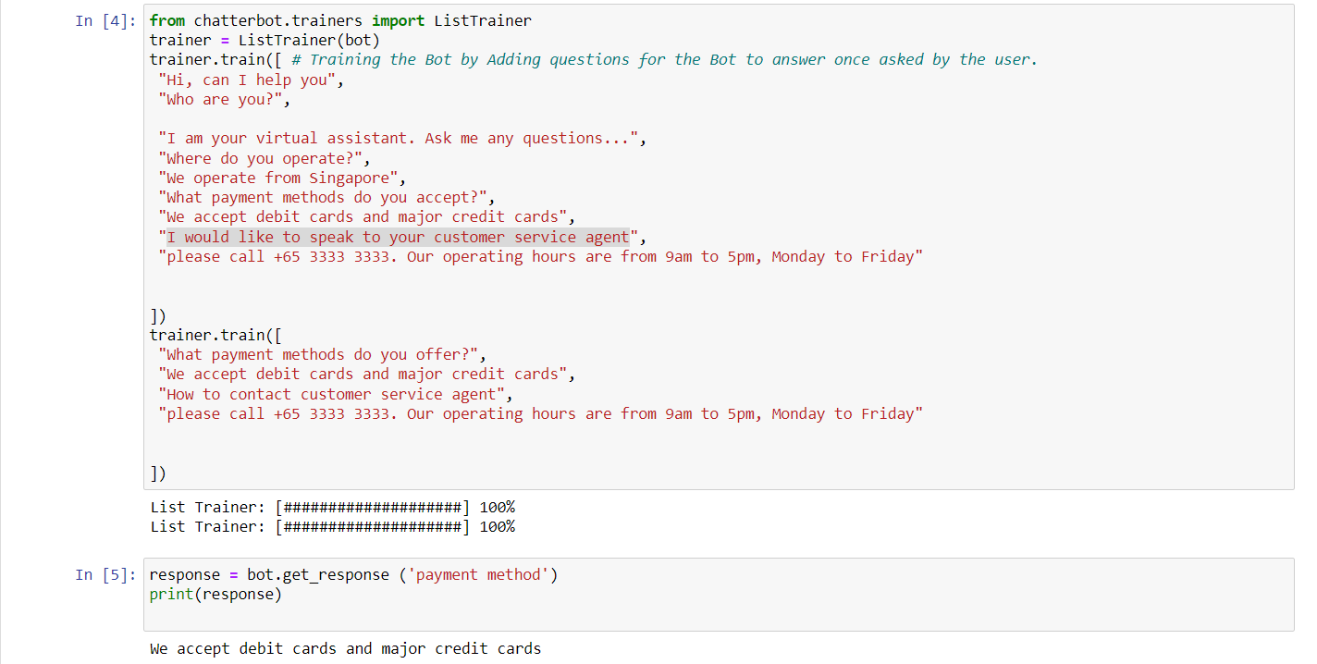

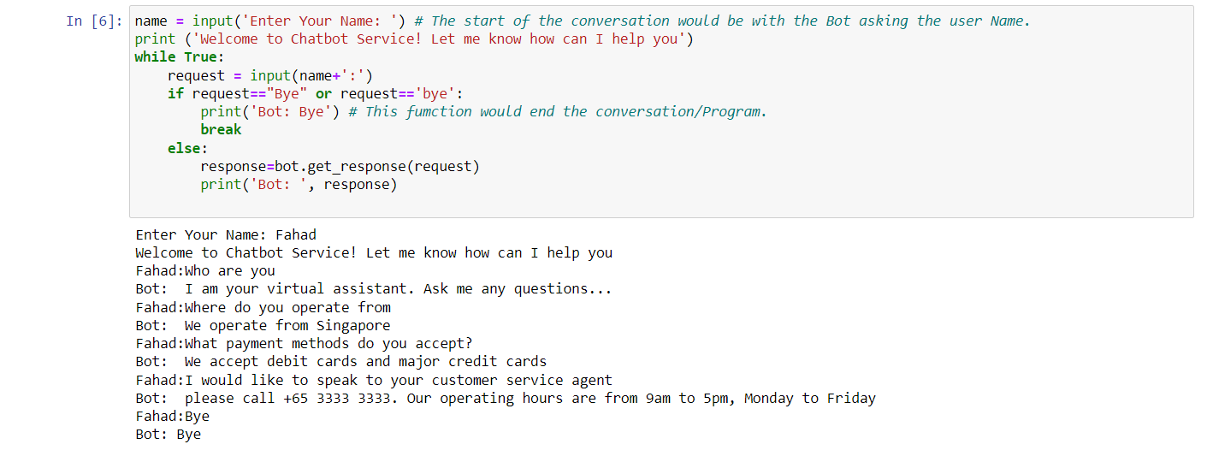

## **Future Enhancement and improvement of the system:**

The implemented chatbot can be modified in many ways and enhanced in many form to provide its user with a great service. Here are some Future enhancement and improvement that can be done for this chatbot:

1. **Multi-Language (multilingual) Chatbot:** The number one enhancement for our chatbot would be to add several other languages in our chatbot which can include Malay, Mandarin, French and many more. With the implementation of this multi-language option the user will find it easy to communicate with the bot in his/her own language to solve and problem that the user is facing.
2. **Communicating with voice/speech/call:** The chatbot can be trained for the user who would prefer to have a medium of communication through calling the chatbot on a specific line number. The user would call to that bot and the bot would answer the call in the same manner as it would with text but this time the chatbot cold actually speak with the user with the addition of choosing a specific language as mentioned in previous point.
3. **Improve chatbot processing capabilities:** The accuracy and usefulness of a chatbot can be increased by teaching it to understand and reply to questions posed in natural language. One approach would be to train the chatbot with state-of-the-art machine learning algorithms to increase its pattern recognition and semantic understanding.

## **Conclusion:**

In conclusion, chatbots are a widely used method for automating customer service and other routine jobs. Natural language processing, multilingual capabilities, and text-to-speech communication are all areas where chatbots are likely to improve as technology develops. With these updates, chatbots will be able to connect with users in a more customised and productive manner, resulting to more satisfied clients and better bottom lines. Therefore, chatbots are likely to play a significant role in the future of human interaction and commerce.